**DAILY ONLINE ACTIVITIES SUMMARY**

|  |  |  |  |  |  |  |  |  |
| --- | --- | --- | --- | --- | --- | --- | --- | --- |
| **Date:** | 18/05/2020 | | | | | **Name:** | D Richard Franklin | |
| **Sem & Sec** | Fourth SEM section A | | | | | **USN:** | 4AL18CS020 | |
| **Online Test Summary** | | | | | | | | |
| **Subject** | | Complex analysis, probability and statistical methods | | | | | | |
| **Max. Marks** | | 30 | | **Score** | | | N/A | |
| **Certification Course Summary** | | | | | | | | |
| **Course** | Complete Python Bootcamp : Go from zero to hero in Python 3 | | | | | | | |
| **Certificate Provider** | | | Udemy | | **Duration** | | | 2 Hours |
| **Coding Challenges** | | | | | | | | |
| **Problem Statement:** 1. Frequency of each letters in a string  2. Printing odd and even numbers using threads  3. To check whether given two strings are anagrams | | | | | | | | |
| **Status: Completed** | | | | | | | | |
| **Uploaded the report in Github** | | | | | YES | | | |
| **If yes Repository name** | | | | | <https://github.com/richard3658/lockdown-coding> | | | |
| **Uploaded the report in slack** | | | | | YES | | | |

**Online Test Details:**

The online test was from module 4 which was about curve fitting and statistical method. There were 30 questions and the duration was 30 minutes. The questions were optimal and were easy. The score for the test was not displayed after the test for some reason.

**Snapshot**: not taken

**Certification Course Details:**

**Name of the course**: Complete Python Bootcamp: Go from zero to hero in Python 3

**Certificate Provider**: Udemy

This course has 19 sections and the total duration is 24 hours.

In the first day I went through the first two sections of the course and learnt the pre-requisites of the whole language and the necessary installing that is needed in one’s pc.

**Snapshot:**

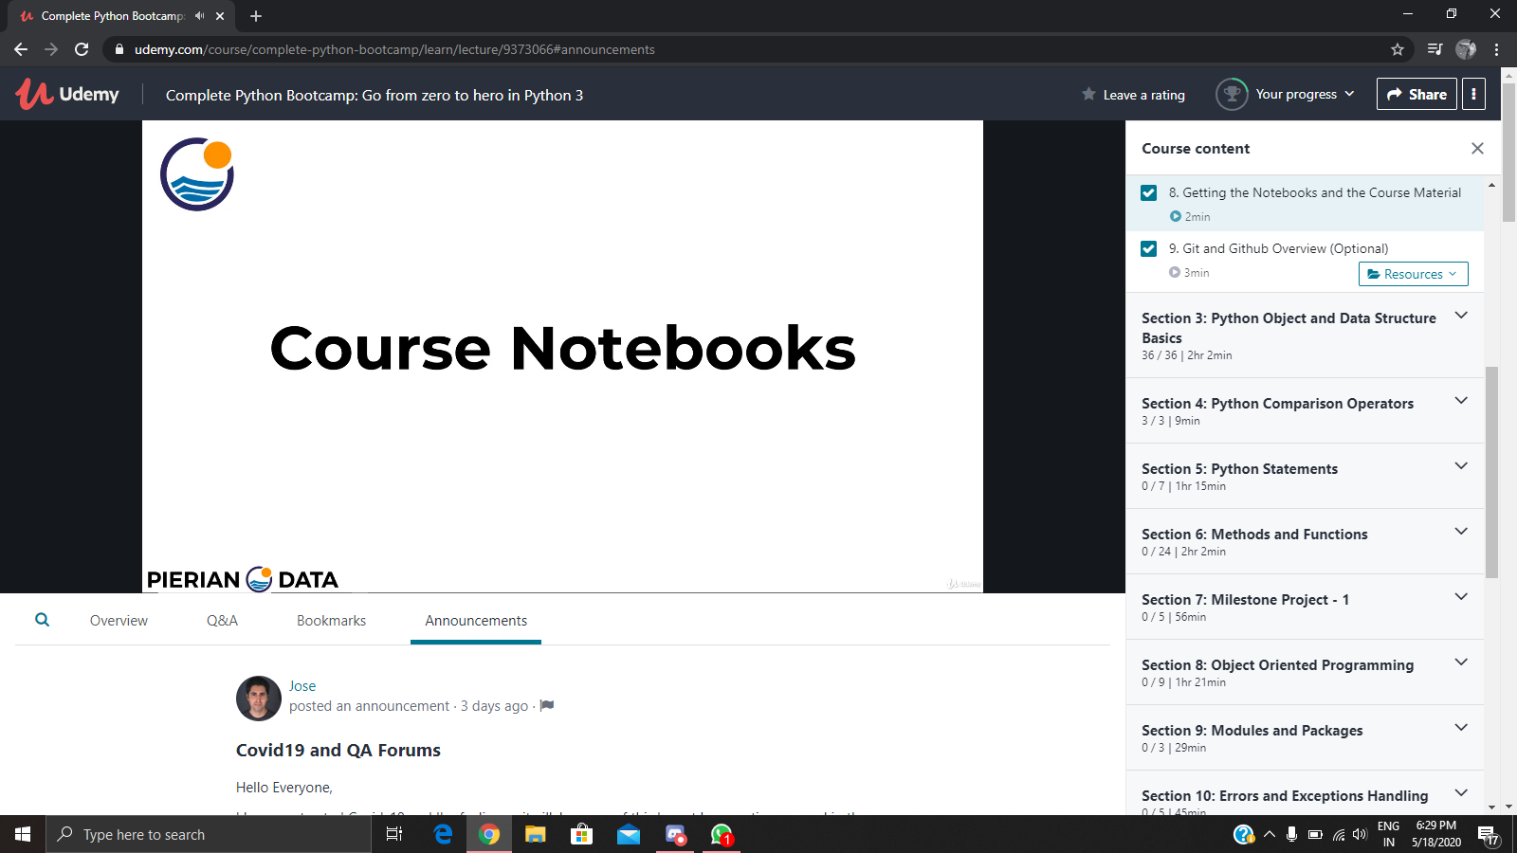

**Online Coding Details:**

Problem 1: (using C language) Check whether the two given strings are anagram or not.

Solution: uploaded in github

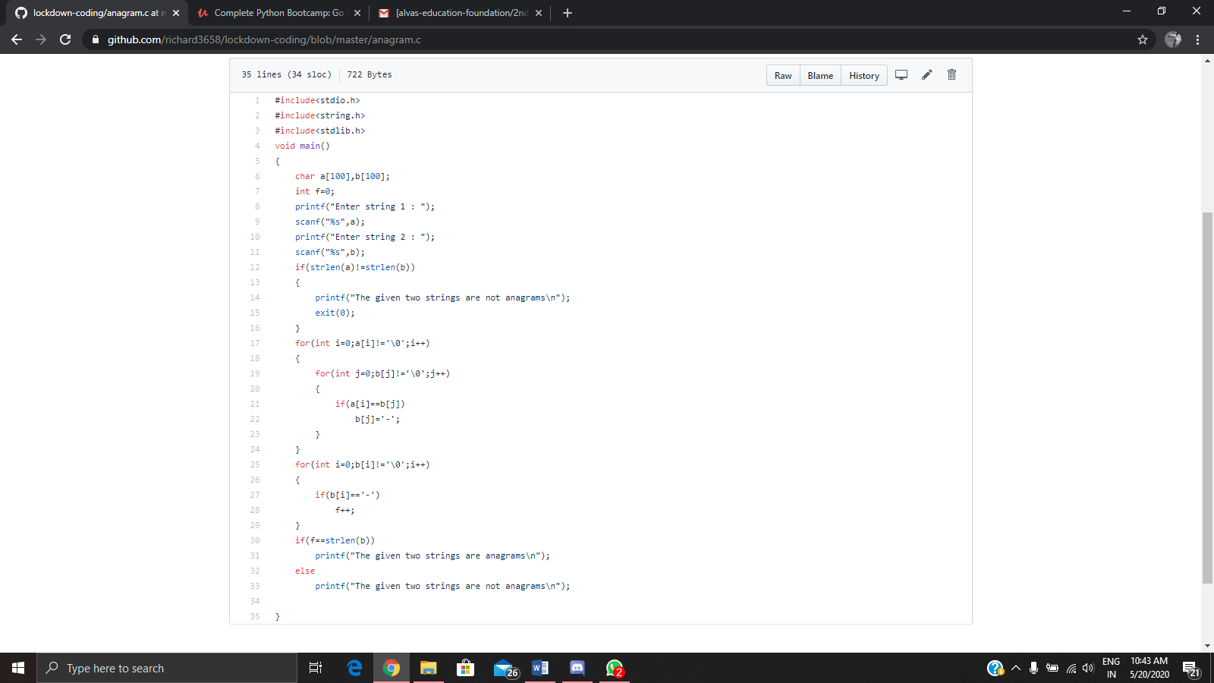

Problem 2: (Using JAVA) Find the frequency of all the letters in a given string.

Solution: uploaded in github

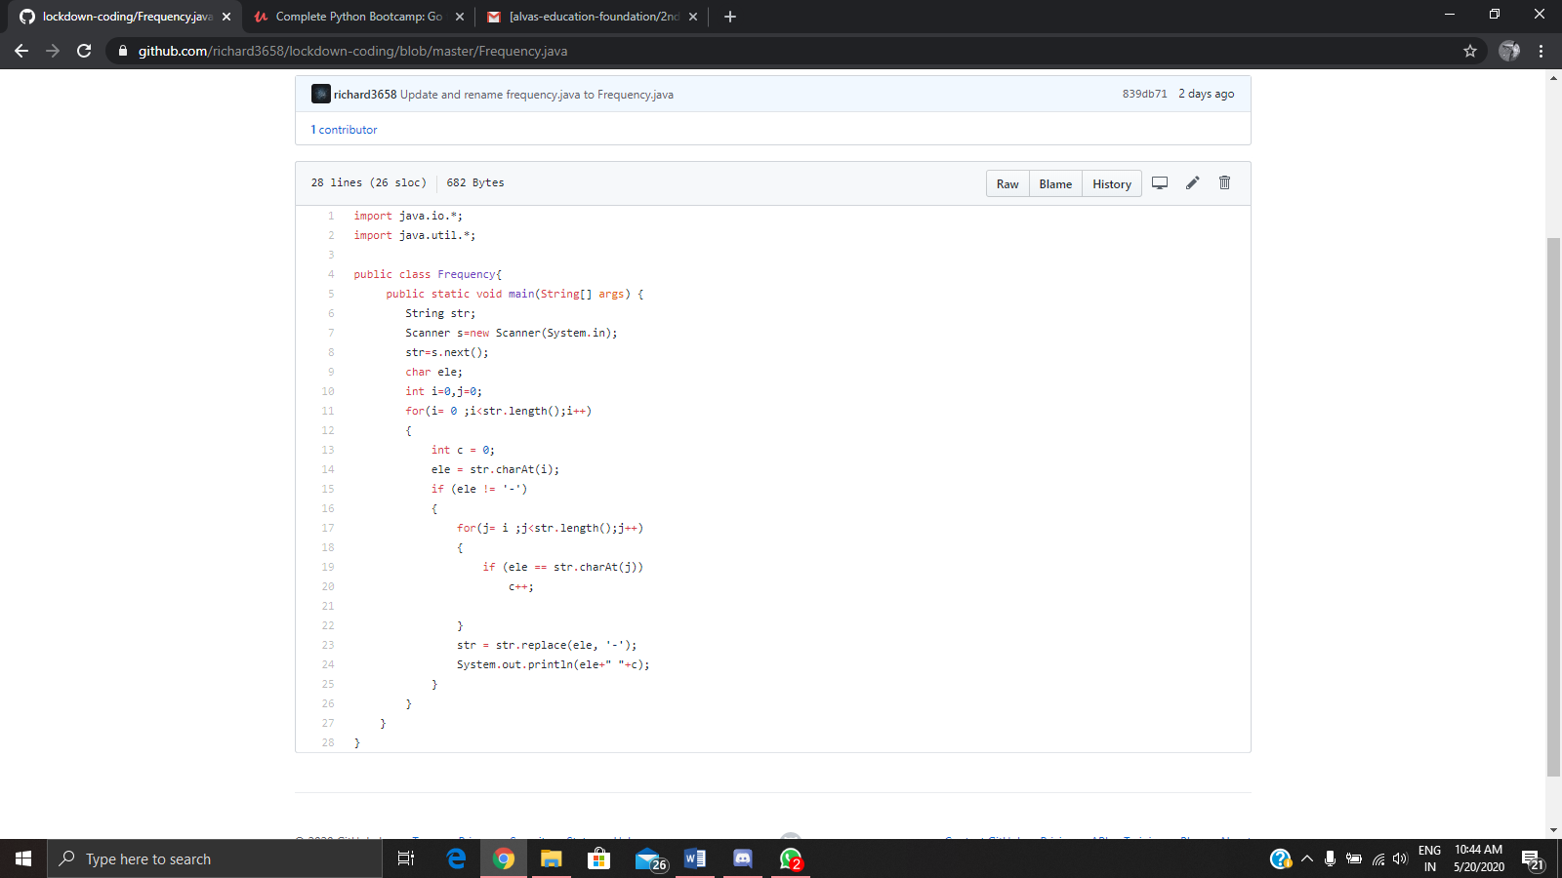

Problem 3: (Using JAVA) write down a java program to print even and odd numbers series respectively from two threads: t1 and t2 synchronizing on a shared object  
Let t1 print message “ping — >” and t2 print message “,—-pong”.

